|  |  |
| --- | --- |
| Riferimento |  |
| Versione | 0.1 |
| Data | 25/01/2020 |
| Destinatario | Prof.ssa F. Ferrucci |
| Presentato da | Marco Delle Cave, Francesco Pagano,  Manuel Pisciotta, Alessia Olivieri |
| Approvato da |  |



Test Execution Report

TutoratoSmart

Revision History

|  |  |  |  |
| --- | --- | --- | --- |
| **Data** | **Versione** | **Cambiamenti** | **Autori** |
| 25/01/2020 | 0.1 | Prima stesura | Delle Cave Marco,  Pagano Francesco, Pisciotta Manuel |

Sommario

AddActivitySuccess 3

AddActivityError 4

AddAppointmentSuccess 5

AddAppointmentError 6

AddRequestSuccess 7

AddRequestError 8

LoginEmailEmpty 9

LoginEmailFormatError 10

LoginPasswordEmpty 11

LoginPasswordFormatError 12

LoginSuccessCommission 13

LoginSuccessStudent 14

LoginSuccessTutor 15

ManageRequestSuccess 16

ManageRequestError 17

ModifyActivitySuccess 18

ModifyActivityError 19

ModifyAppointmentSuccess 20

ModifyAppointmentError 21

ModifyRequestSuccess 22

ModifyRequestError 23

RegistrationNameFormatError 24

RegistrationPasswordsDifferentError 25

RegistrationStudentSuccess 26

RegistrationTutorSuccess 27

## AddActivitySuccess

|  |  |  |
| --- | --- | --- |
| **NOME** | AddActivitySuccess | |
| **DATA** | 25/01/20 | |
| **OUTPUT ATTESO** | | |
| Corretto | | |
| **OUTPUT SISTEMA** | | |
| Corretto | | |
| **ESITO** | | Corretto |

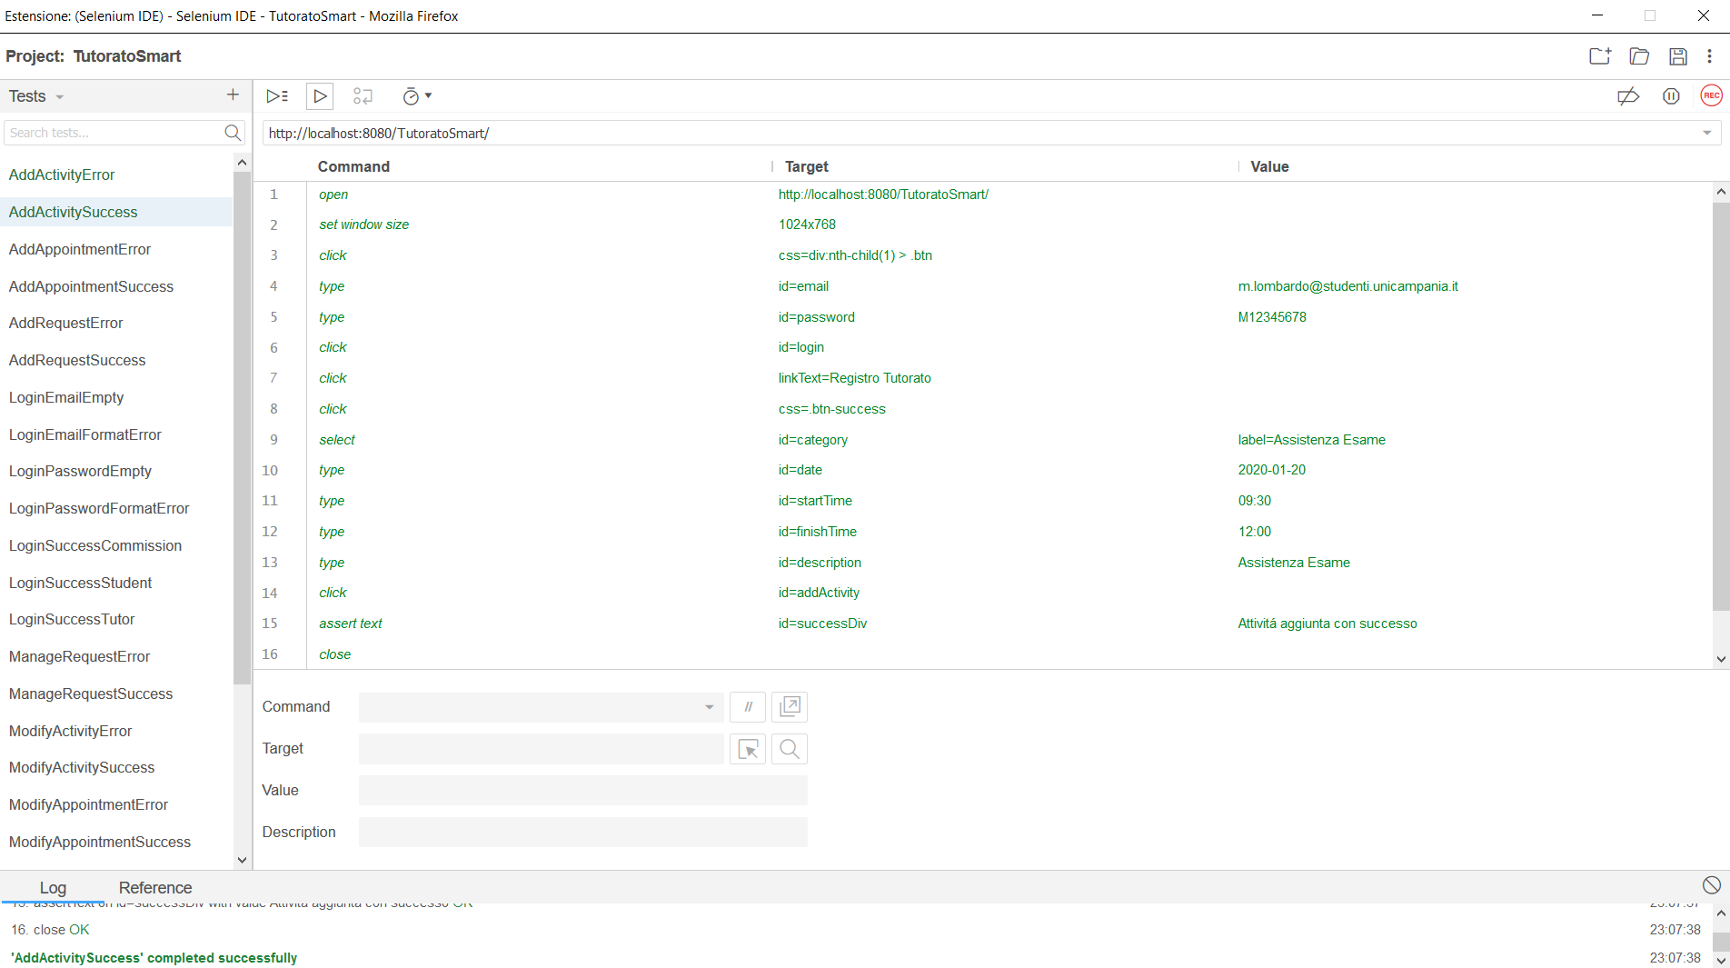

## AddActivityError

|  |  |  |
| --- | --- | --- |
| **NOME** | AddActivityError | |
| **DATA** | 25/01/20 | |
| **OUTPUT ATTESO** | | |
| Errore | | |
| **OUTPUT SISTEMA** | | |
| Errore | | |
| **ESITO** | | Corretto |

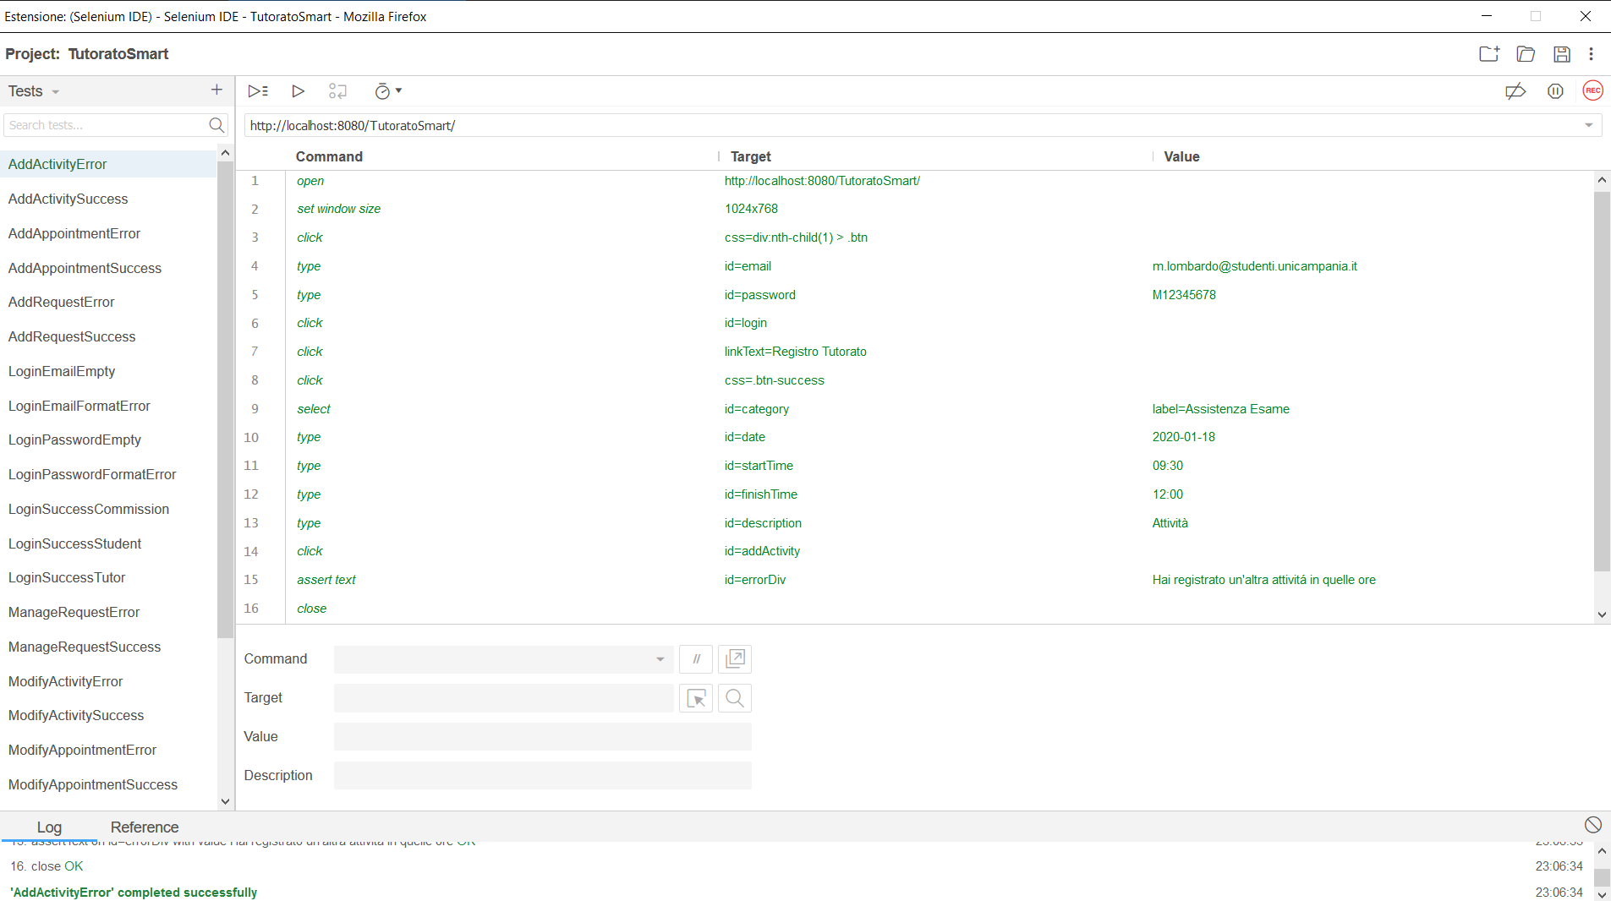

## AddAppointmentSuccess

|  |  |  |
| --- | --- | --- |
| **NOME** | AddAppointmentSuccess | |
| **DATA** | 25/01/20 | |
| **OUTPUT ATTESO** | | |
| Corretto | | |
| **OUTPUT SISTEMA** | | |
| Corretto | | |
| **ESITO** | | Corretto |

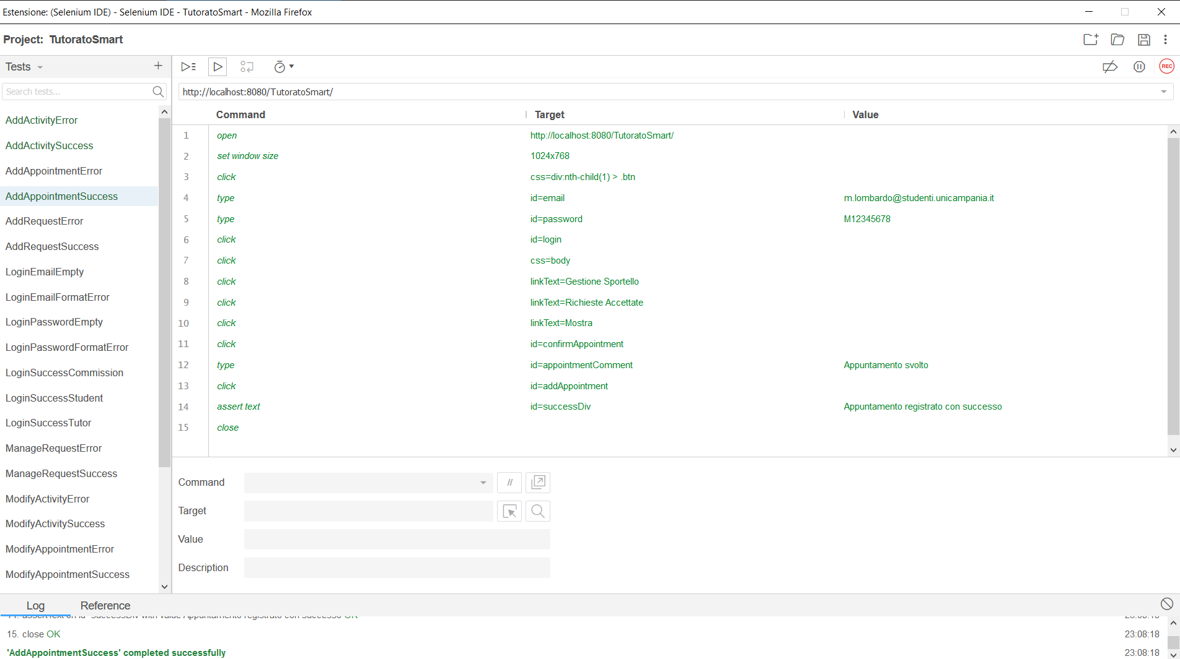

## AddAppointmentError

|  |  |  |
| --- | --- | --- |
| **NOME** | AddAppointmentError | |
| **DATA** | 25/01/20 | |
| **OUTPUT ATTESO** | | |
| Errore | | |
| **OUTPUT SISTEMA** | | |
| Errore | | |
| **ESITO** | | Corretto |

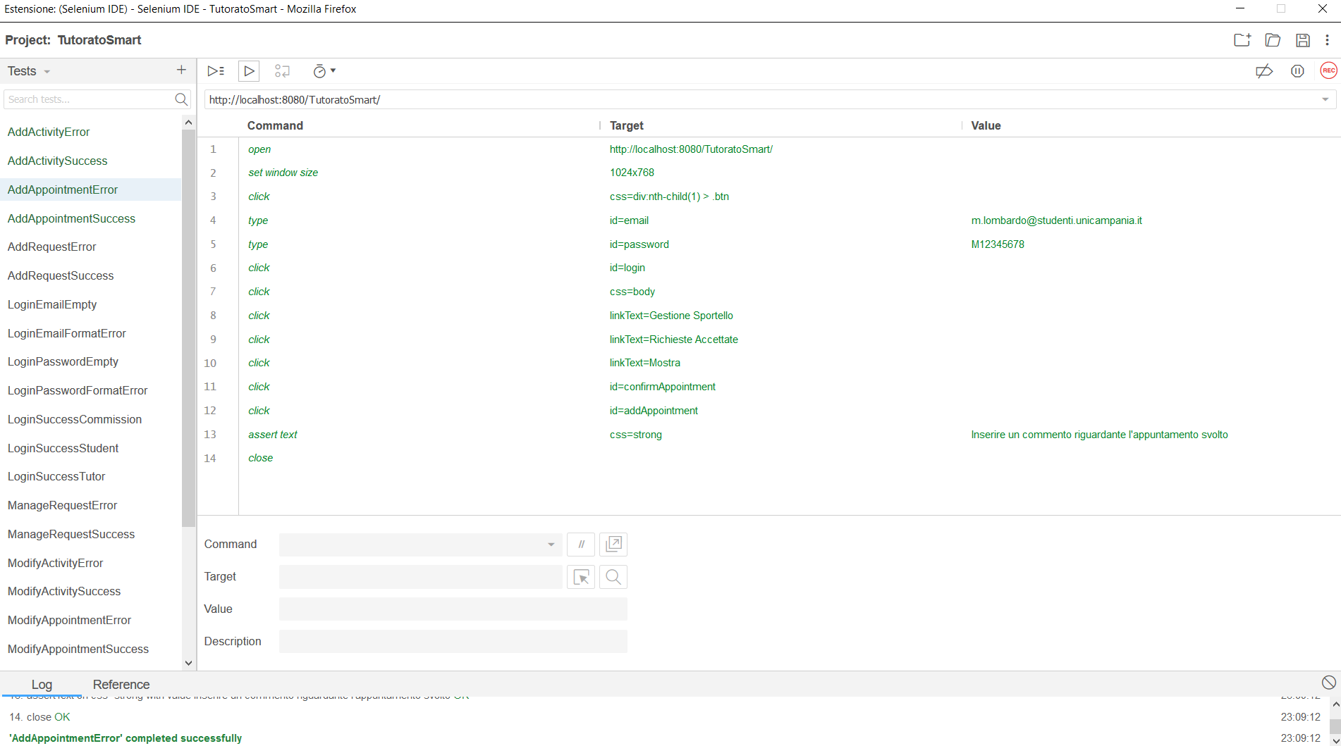

## AddRequestSuccess

|  |  |  |
| --- | --- | --- |
| **NOME** | AddRequestSuccess | |
| **DATA** | 25/01/20 | |
| **OUTPUT ATTESO** | | |
| Corretto | | |
| **OUTPUT SISTEMA** | | |
| Corretto | | |
| **ESITO** | | Corretto |

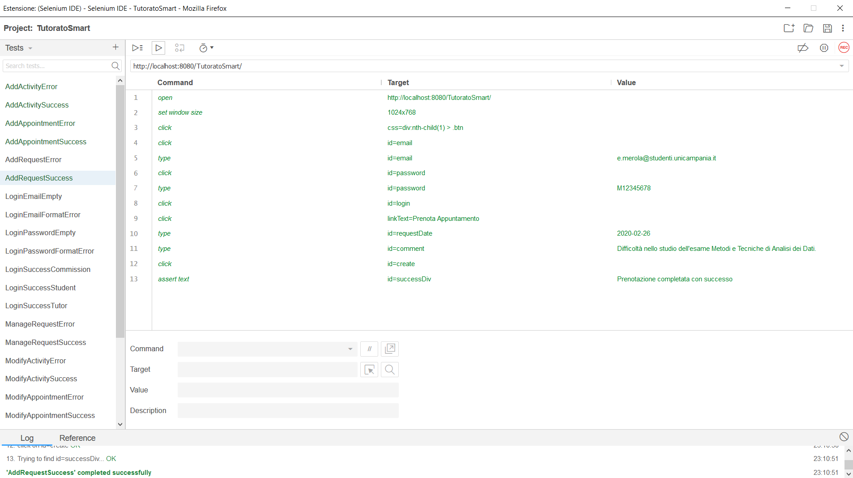

## AddRequestError

|  |  |  |
| --- | --- | --- |
| **NOME** | AddRequestError | |
| **DATA** | 25/01/20 | |
| **OUTPUT ATTESO** | | |
| Errore | | |
| **OUTPUT SISTEMA** | | |
| Errore | | |
| **ESITO** | | Corretto |

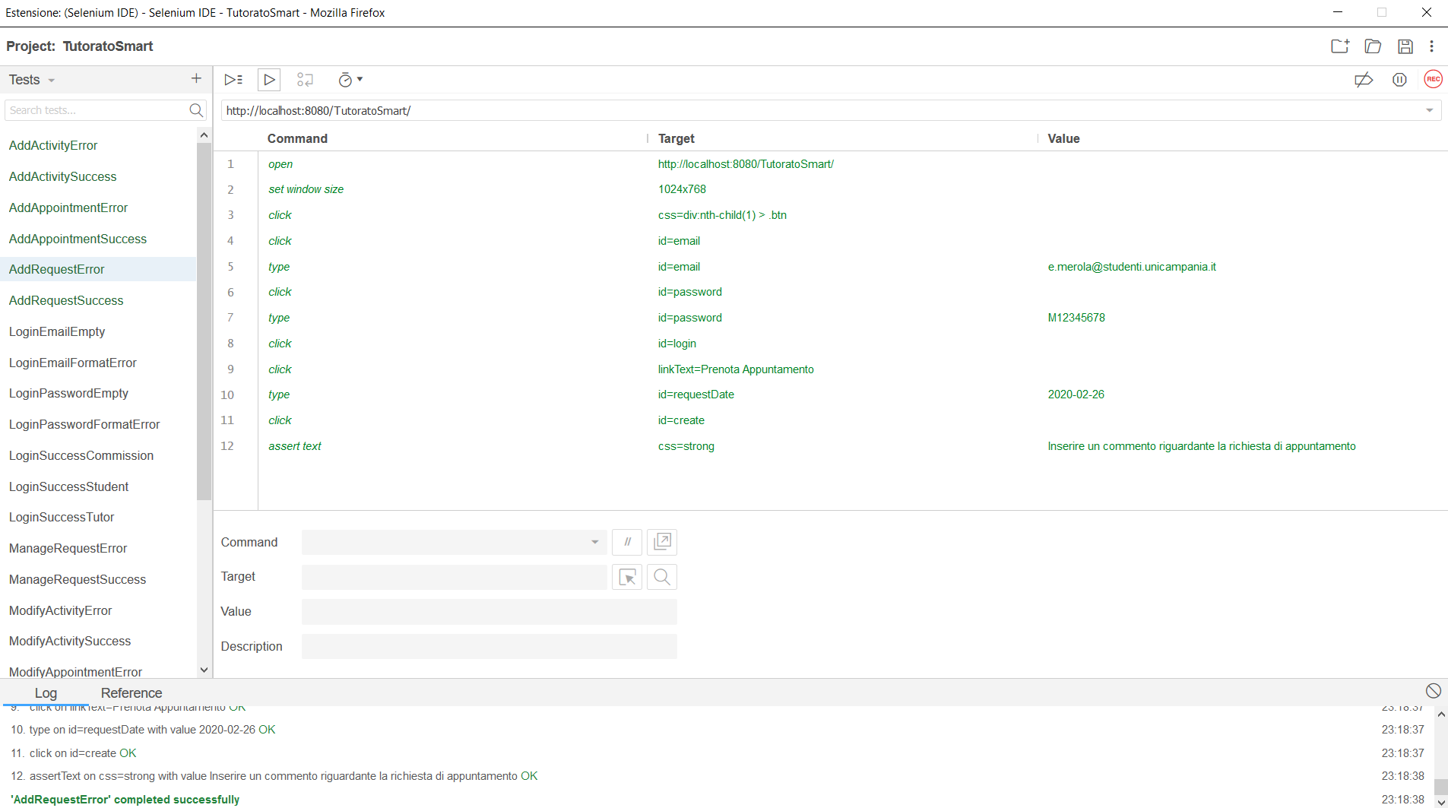

## LoginEmailEmpty

|  |  |  |
| --- | --- | --- |
| **NOME** | LoginEmailEmpty | |
| **DATA** | 25/01/20 | |
| **OUTPUT ATTESO** | | |
| Errore | | |
| **OUTPUT SISTEMA** | | |
| Errore | | |
| **ESITO** | | Corretto |

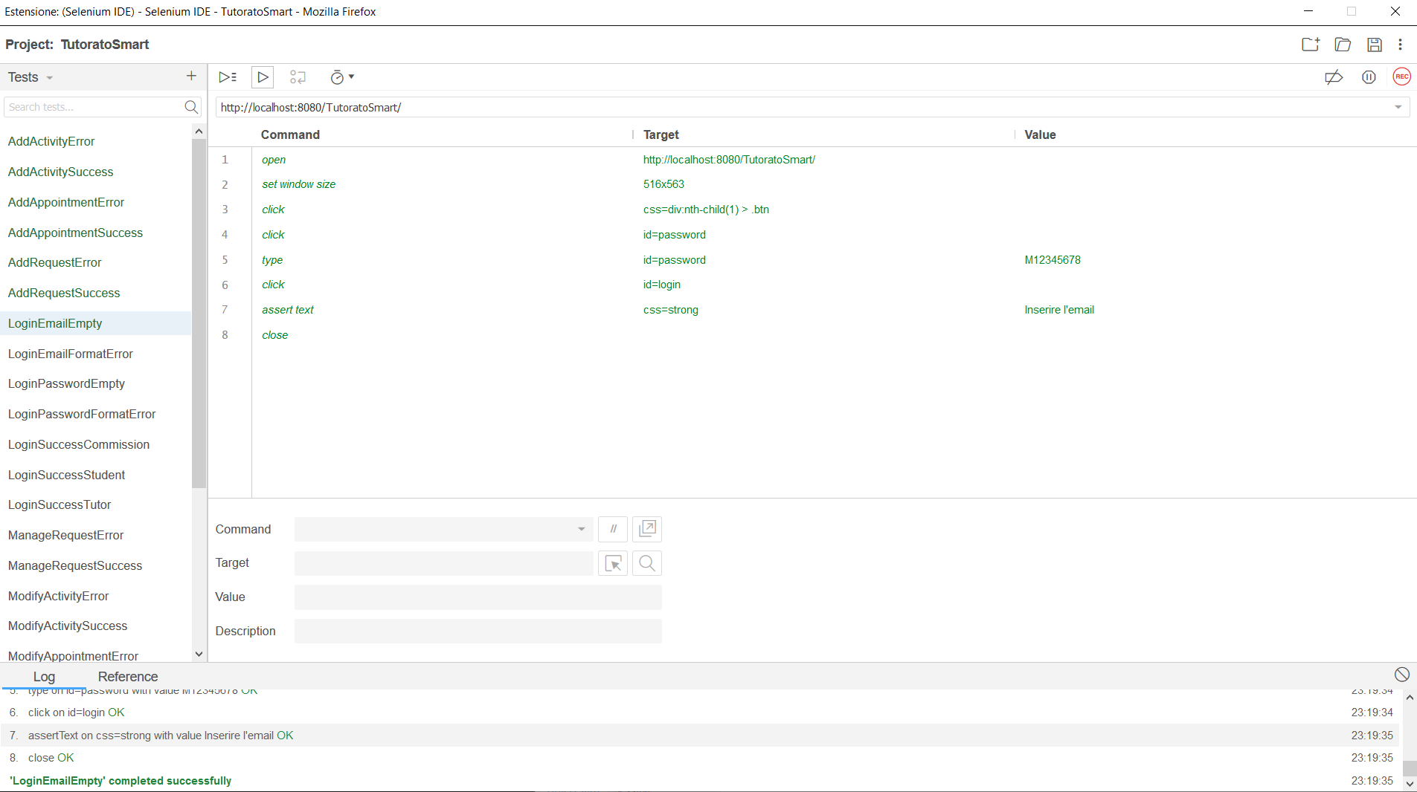

## LoginEmailFormatError

|  |  |  |
| --- | --- | --- |
| **NOME** | LoginEmailFormatError | |
| **DATA** | 25/01/20 | |
| **OUTPUT ATTESO** | | |
| Errore | | |
| **OUTPUT SISTEMA** | | |
| Errore | | |
| **ESITO** | | Corretto |

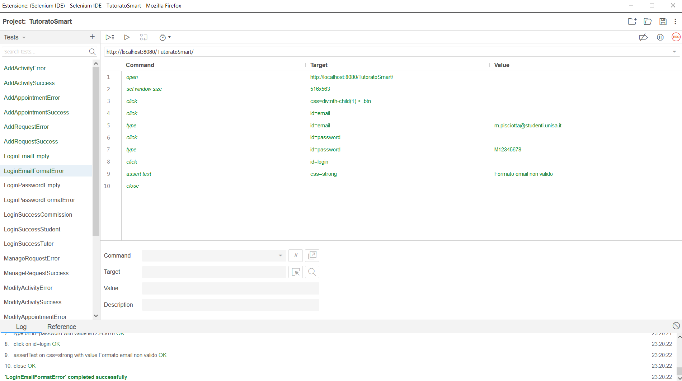

## LoginPasswordEmpty

|  |  |  |
| --- | --- | --- |
| **NOME** | LoginPasswordEmpty | |
| **DATA** | 25/01/20 | |
| **OUTPUT ATTESO** | | |
| Errore | | |
| **OUTPUT SISTEMA** | | |
| Errore | | |
| **ESITO** | | Corretto |

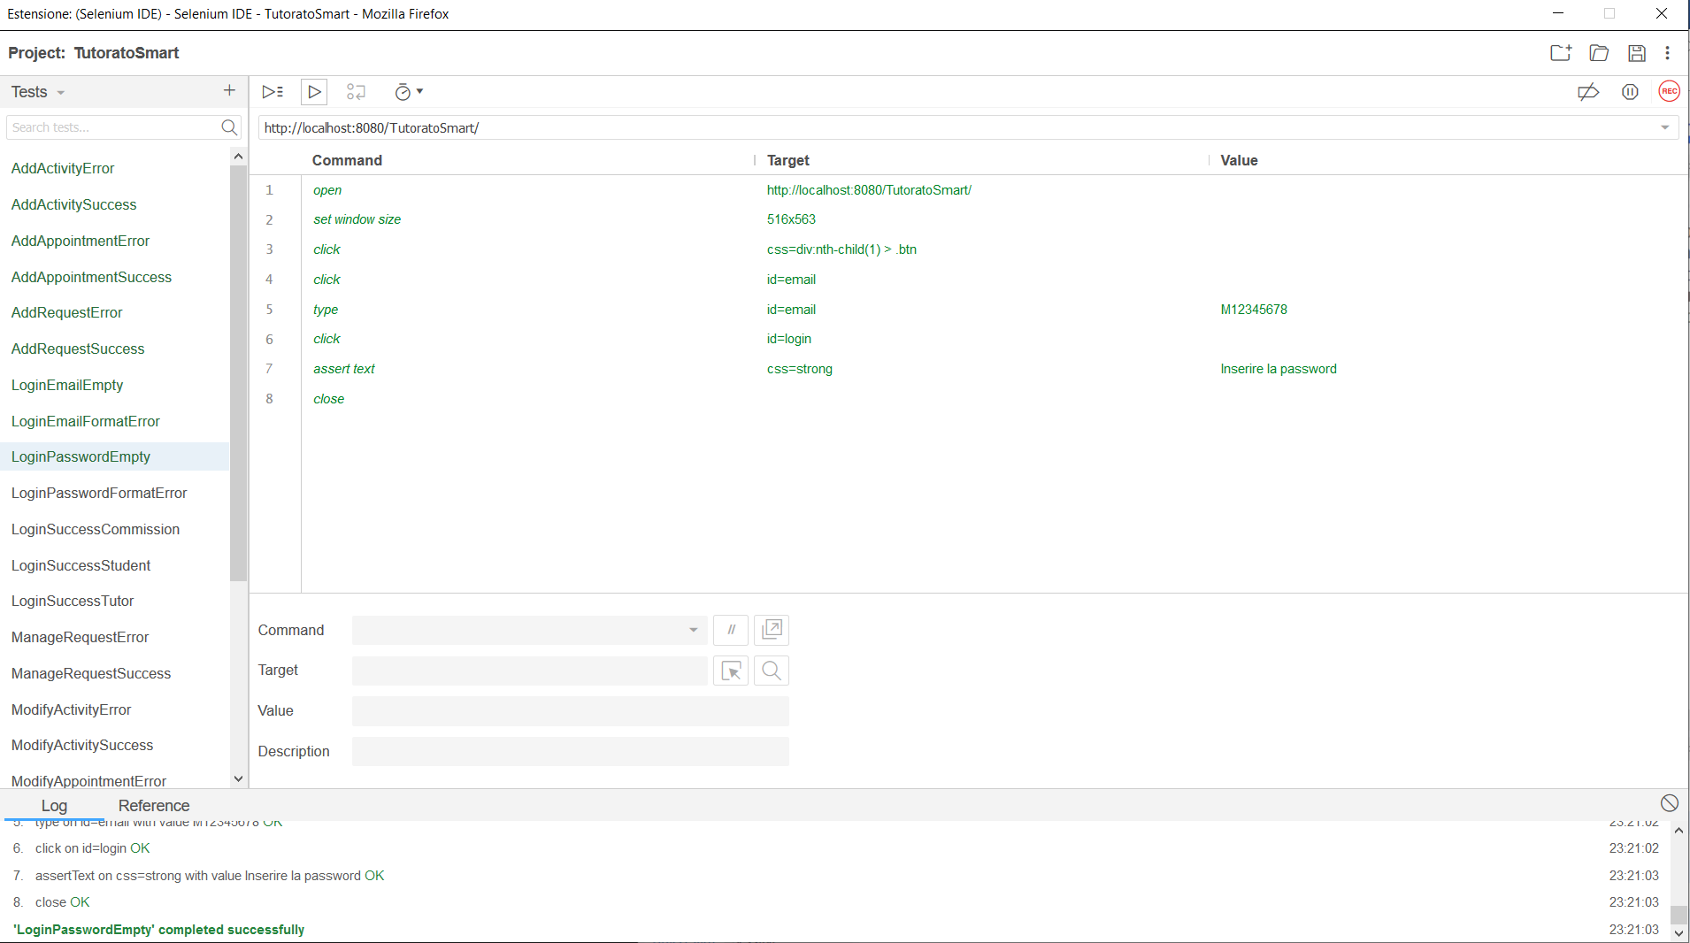

## LoginPasswordFormatError

|  |  |  |
| --- | --- | --- |
| **NOME** | LoginPasswordFormatError | |
| **DATA** | 25/01/20 | |
| **OUTPUT ATTESO** | | |
| Errore | | |
| **OUTPUT SISTEMA** | | |
| Errore | | |
| **ESITO** | | Corretto |

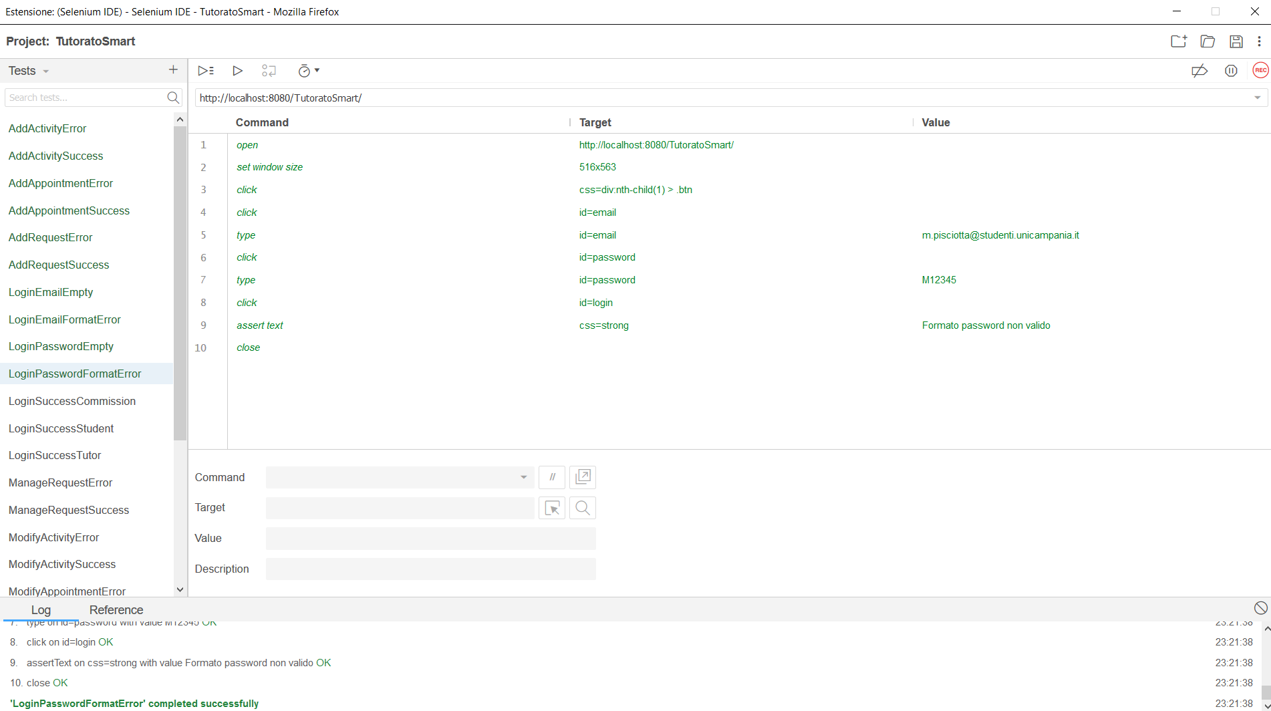

## LoginSuccessCommission

|  |  |  |
| --- | --- | --- |
| **NOME** | LoginSuccessCommission | |
| **DATA** | 25/01/20 | |
| **OUTPUT ATTESO** | | |
| Corretto | | |
| **OUTPUT SISTEMA** | | |
| Corretto | | |
| **ESITO** | | Corretto |

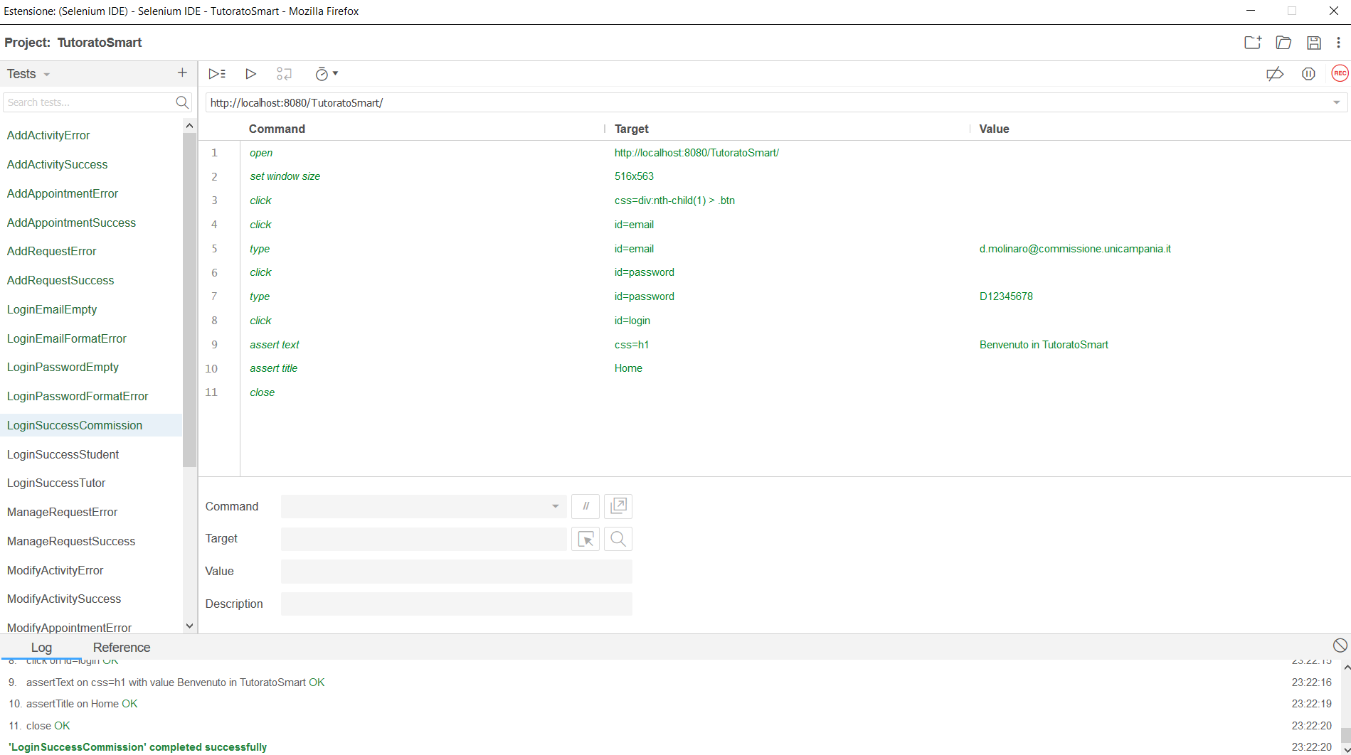

## LoginSuccessStudent

|  |  |  |
| --- | --- | --- |
| **NOME** | LoginSuccessStudent | |
| **DATA** | 25/01/20 | |
| **OUTPUT ATTESO** | | |
| Corretto | | |
| **OUTPUT SISTEMA** | | |
| Corretto | | |
| **ESITO** | | Corretto |

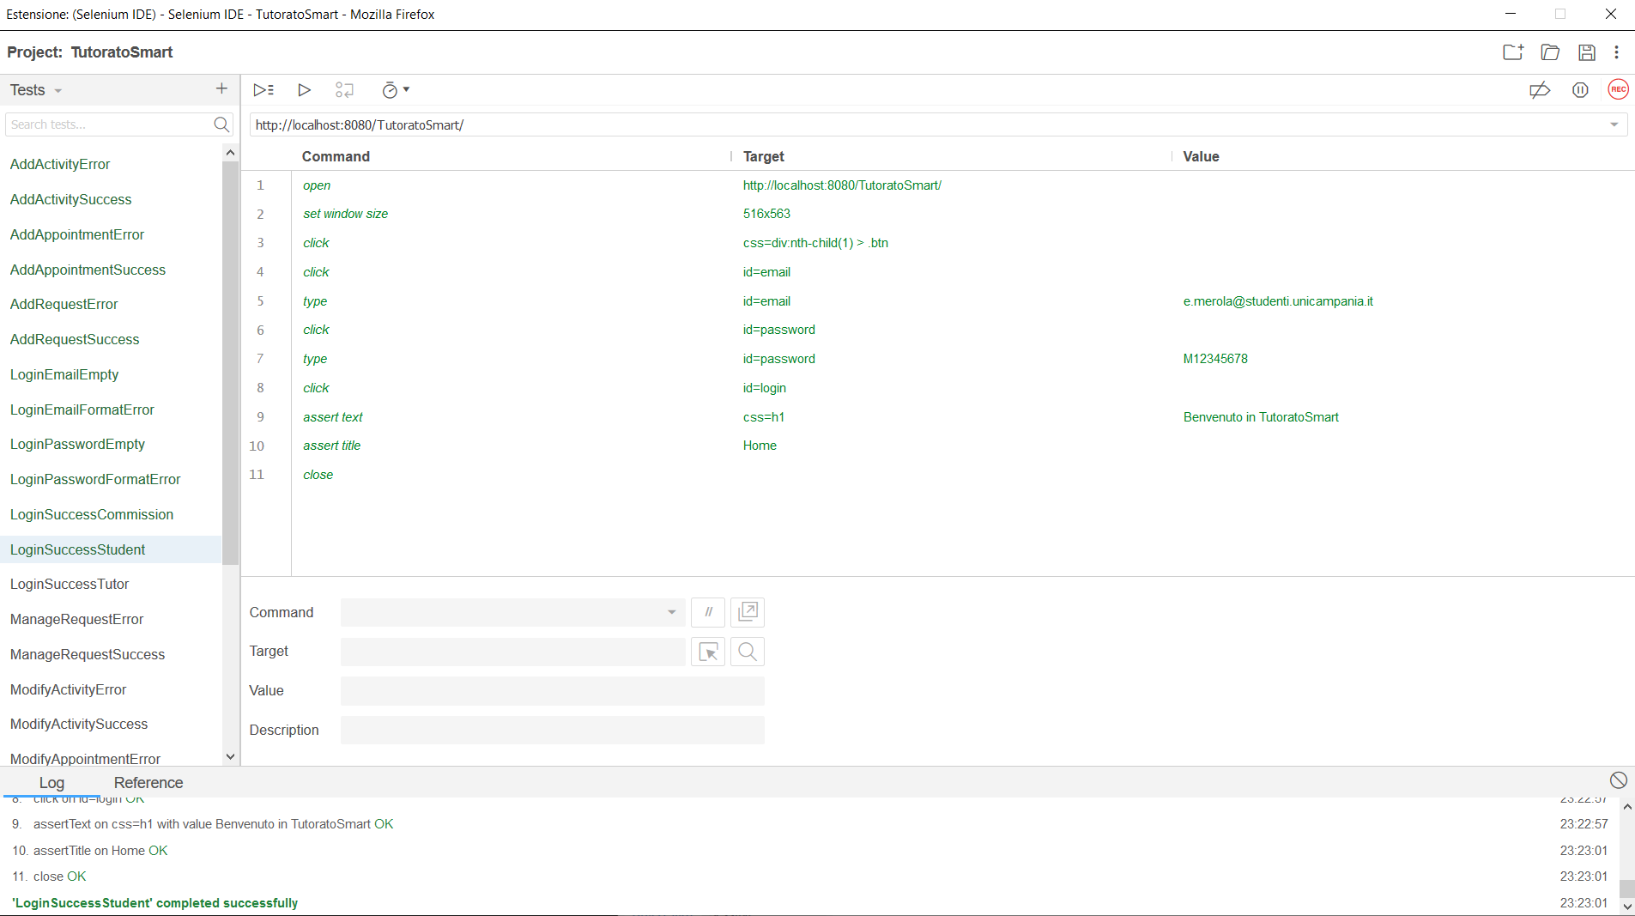

## LoginSuccessTutor

|  |  |  |
| --- | --- | --- |
| **NOME** | LoginSuccessTutor | |
| **DATA** | 25/01/20 | |
| **OUTPUT ATTESO** | | |
| Corretto | | |
| **OUTPUT SISTEMA** | | |
| Corretto | | |
| **ESITO** | | Corretto |

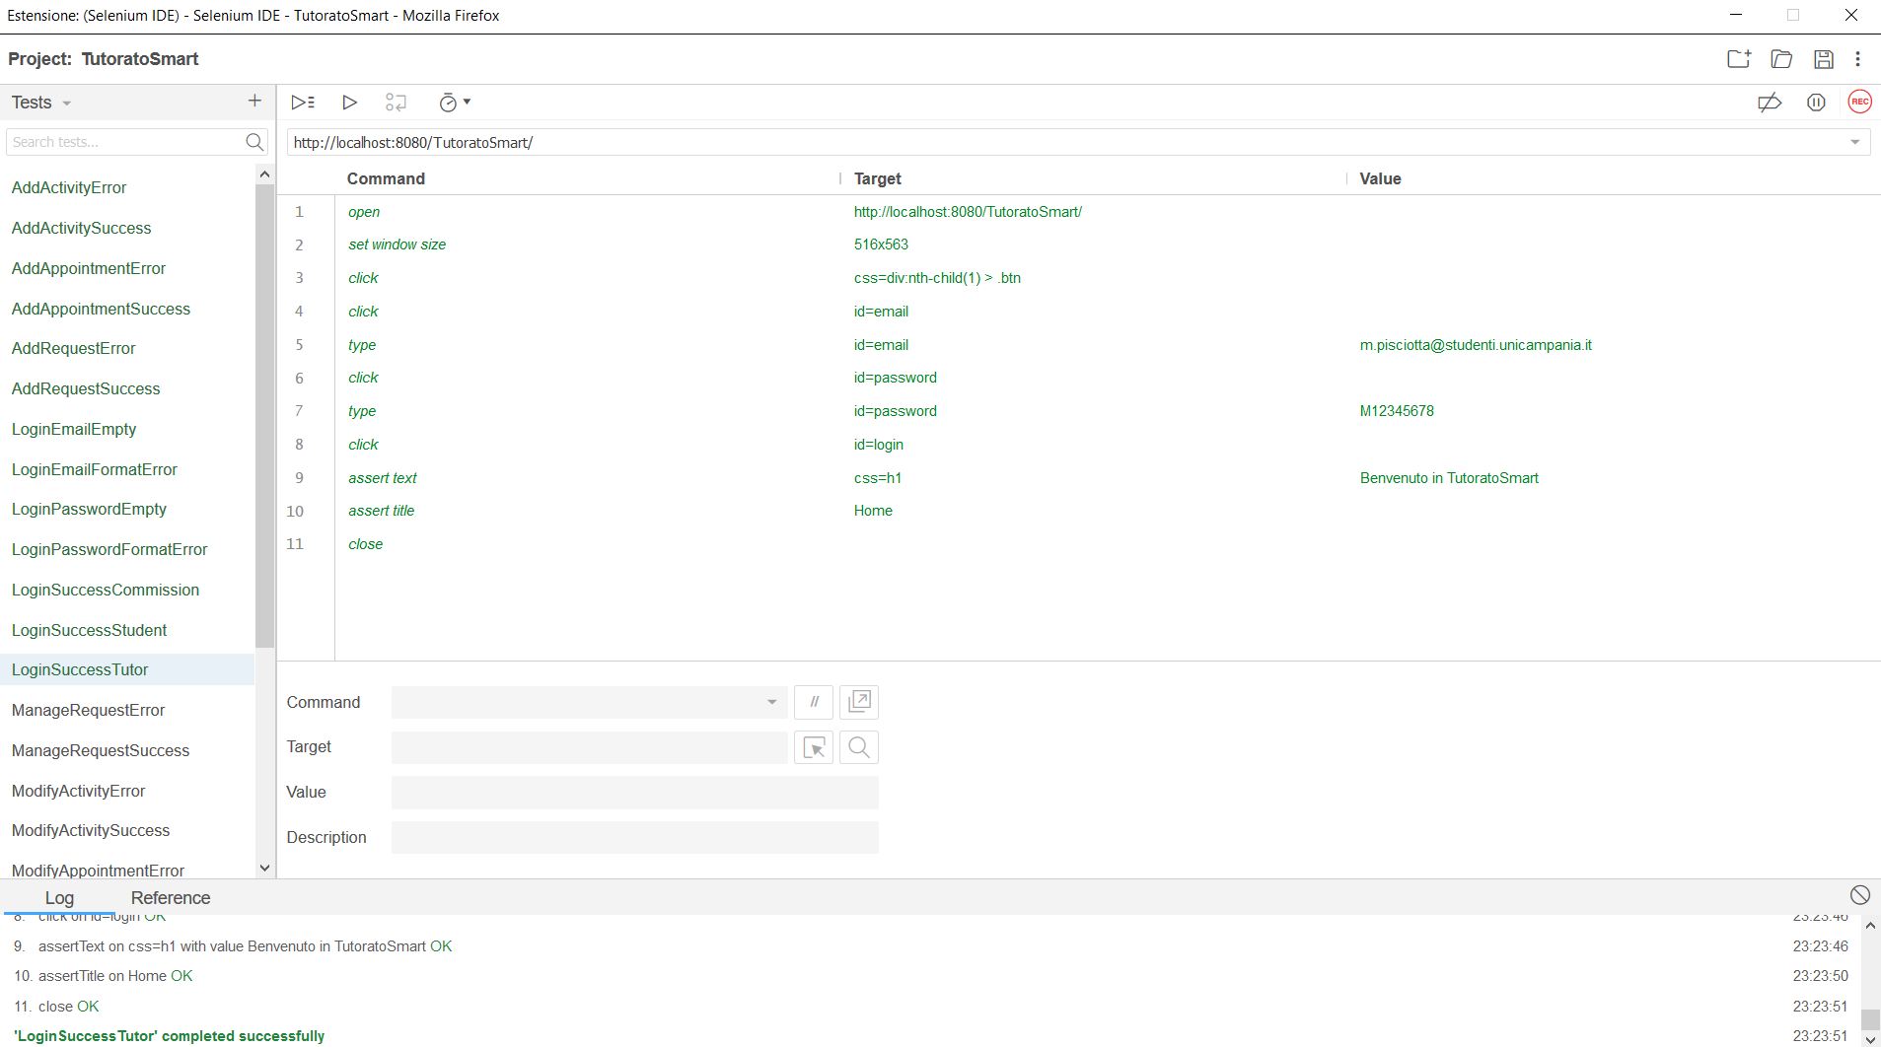

## ManageRequestSuccess

|  |  |  |
| --- | --- | --- |
| **NOME** | ManageRequestSuccess | |
| **DATA** | 25/01/20 | |
| **OUTPUT ATTESO** | | |
| Corretto | | |
| **OUTPUT SISTEMA** | | |
| Corretto | | |
| **ESITO** | | Corretto |

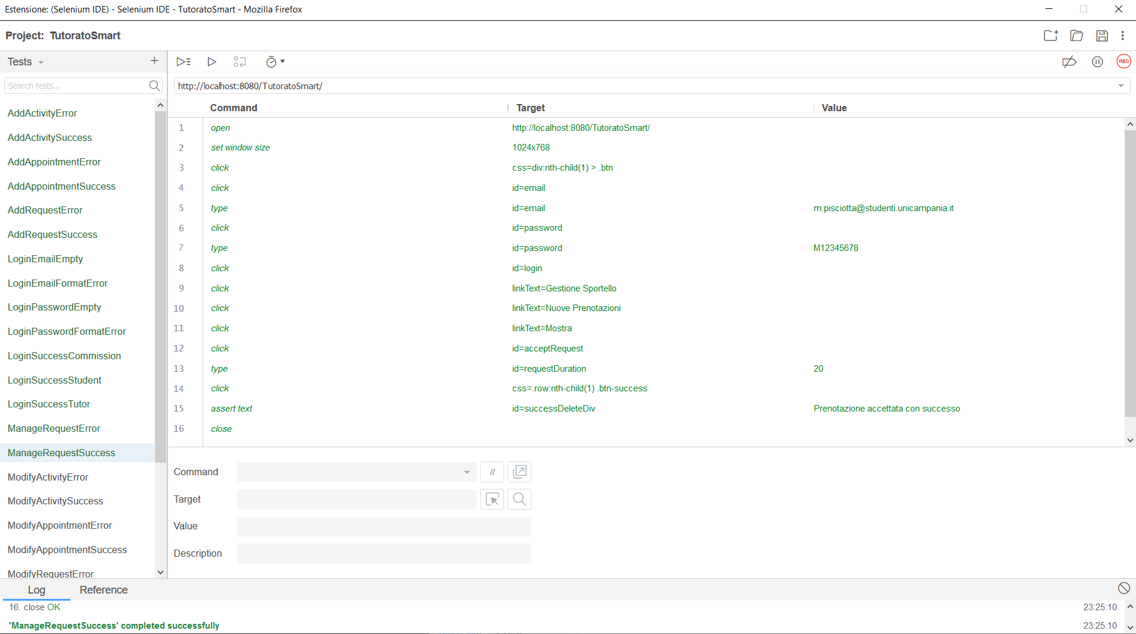

## ManageRequestError

|  |  |  |
| --- | --- | --- |
| **NOME** | ManageRequestError | |
| **DATA** | 25/01/20 | |
| **OUTPUT ATTESO** | | |
| Errore | | |
| **OUTPUT SISTEMA** | | |
| Errore | | |
| **ESITO** | | Corretto |

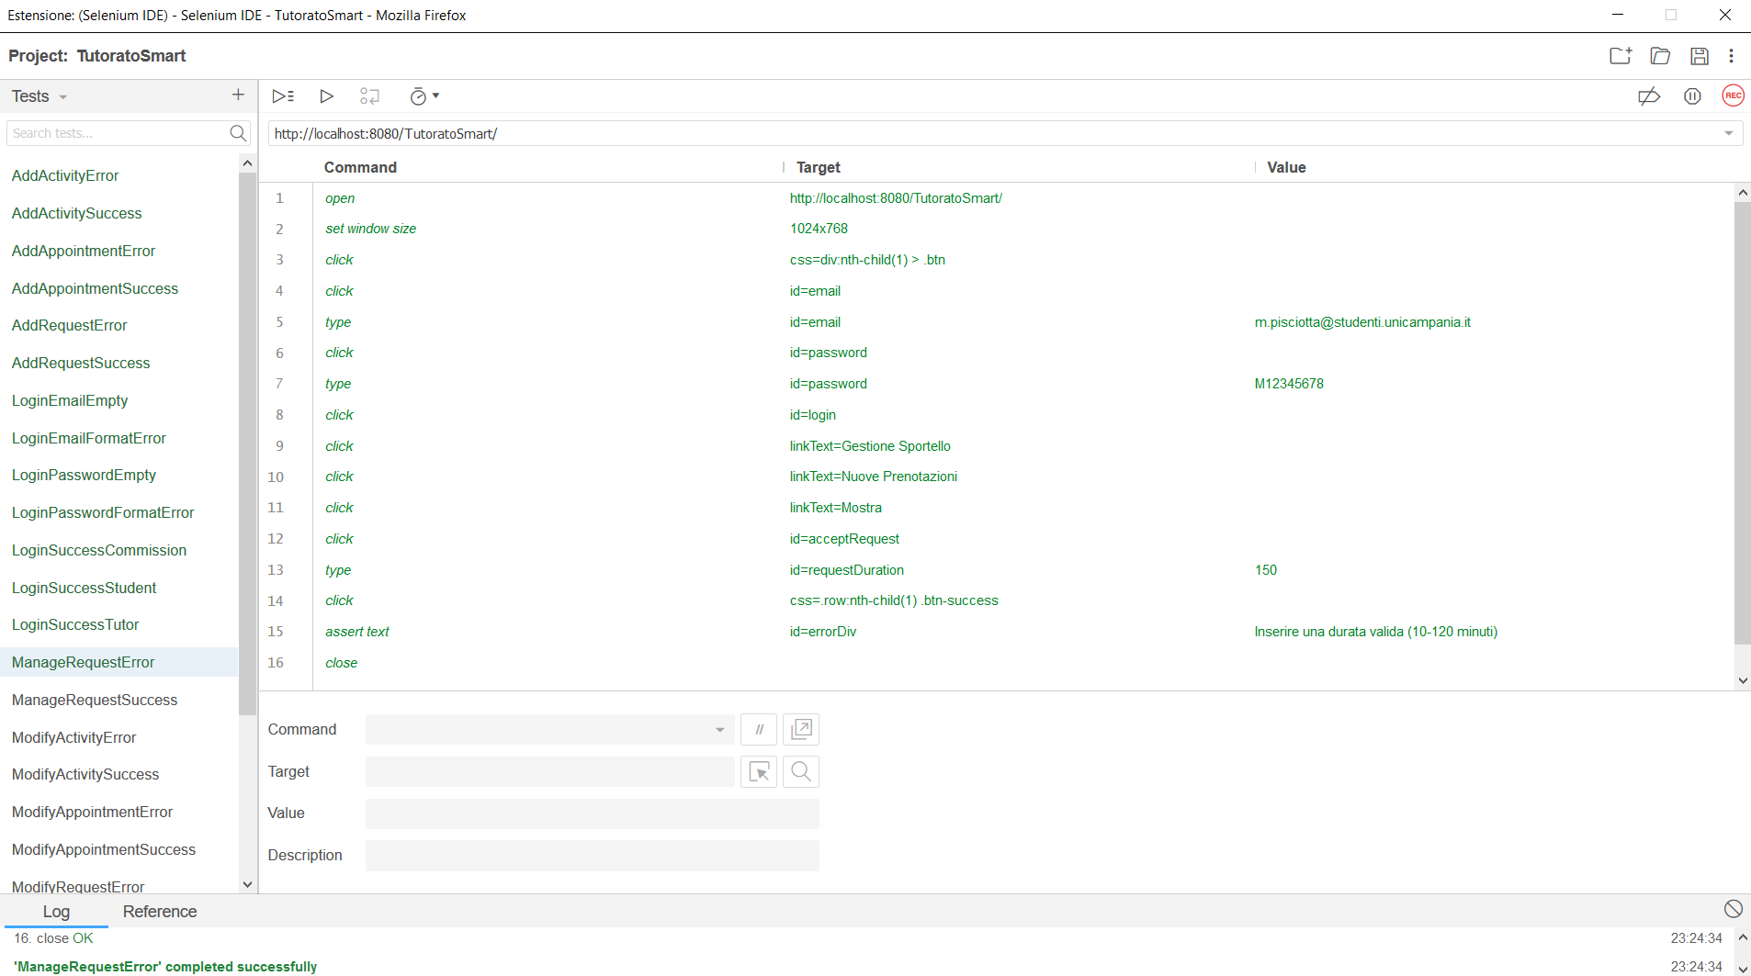

## ModifyActivitySuccess

|  |  |  |
| --- | --- | --- |
| **NOME** | ModifyActivitySuccess | |
| **DATA** | 25/01/20 | |
| **OUTPUT ATTESO** | | |
| Corretto | | |
| **OUTPUT SISTEMA** | | |
| Corretto | | |
| **ESITO** | | Corretto |

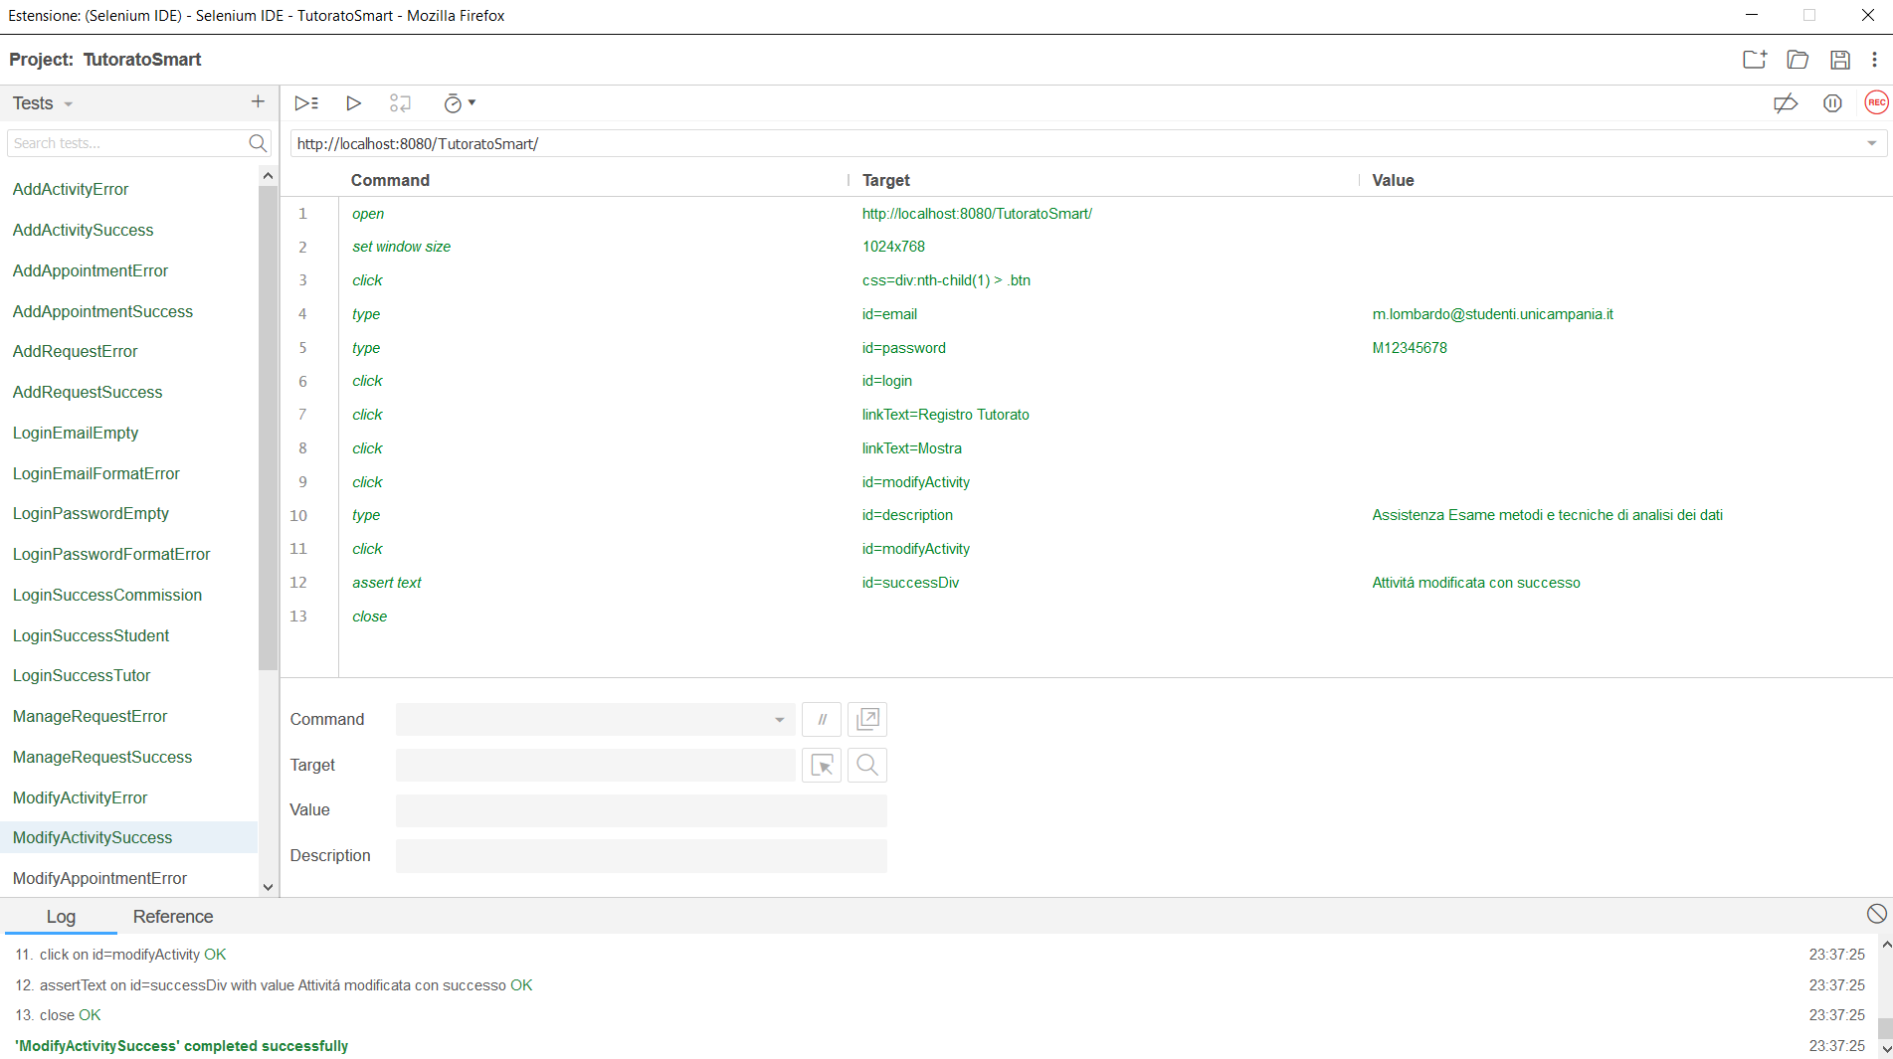

## ModifyActivityError

|  |  |  |
| --- | --- | --- |
| **NOME** | ModifyActivityError | |
| **DATA** | 25/01/20 | |
| **OUTPUT ATTESO** | | |
| Errore | | |
| **OUTPUT SISTEMA** | | |
| Errore | | |
| **ESITO** | | Corretto |

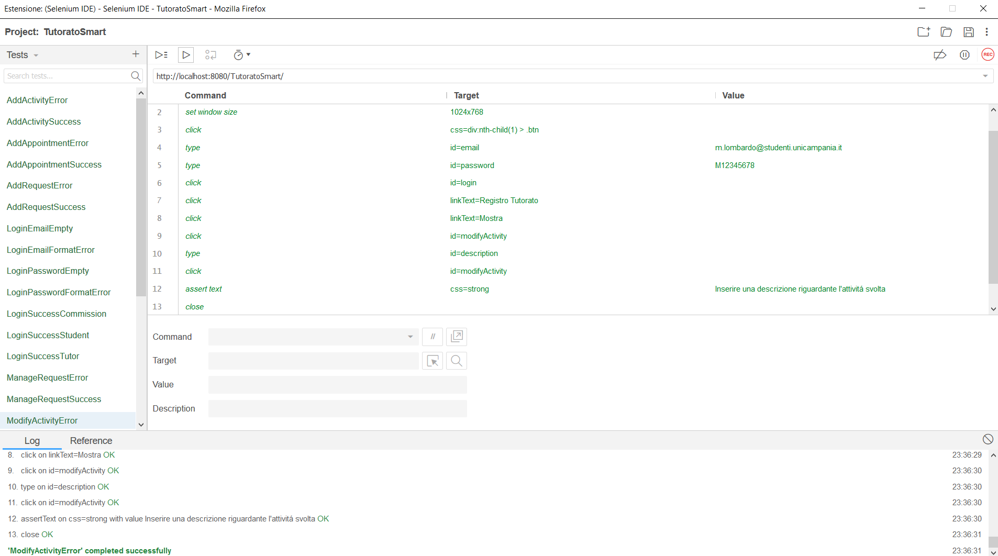

## ModifyAppointmentSuccess

|  |  |  |
| --- | --- | --- |
| **NOME** | ModifyAppintmentSuccess | |
| **DATA** | 25/01/20 | |
| **OUTPUT ATTESO** | | |
| Corretto | | |
| **OUTPUT SISTEMA** | | |
| Corretto | | |
| **ESITO** | | Corretto |

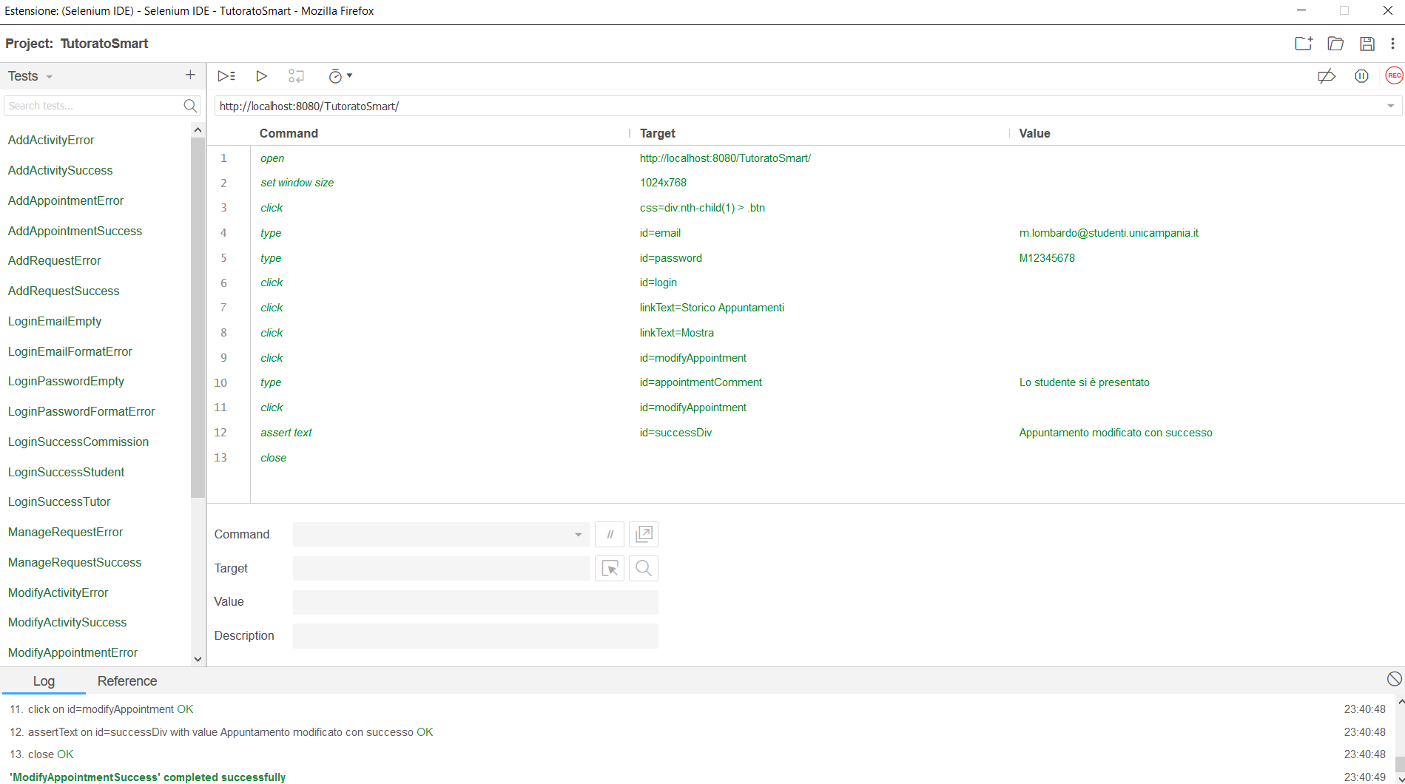

## ModifyAppointmentError

|  |  |  |
| --- | --- | --- |
| **NOME** | ModifyAppointmentError | |
| **DATA** | 25/01/20 | |
| **OUTPUT ATTESO** | | |
| Errore | | |
| **OUTPUT SISTEMA** | | |
| Errore | | |
| **ESITO** | | Corretto |

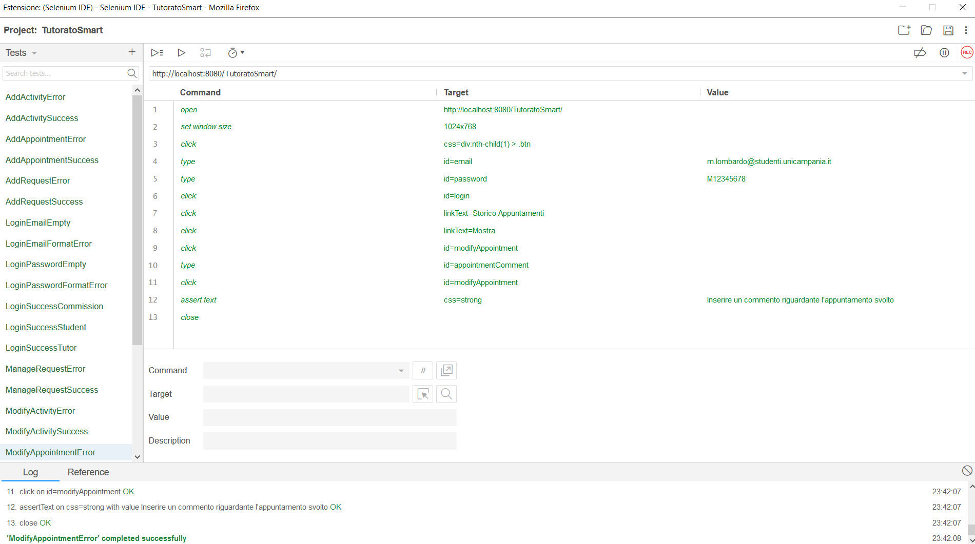

## ModifyRequestSuccess

|  |  |  |
| --- | --- | --- |
| **NOME** | ModifyRequestSuccess | |
| **DATA** | 25/01/20 | |
| **OUTPUT ATTESO** | | |
| Corretto | | |
| **OUTPUT SISTEMA** | | |
| Corretto | | |
| **ESITO** | | Corretto |

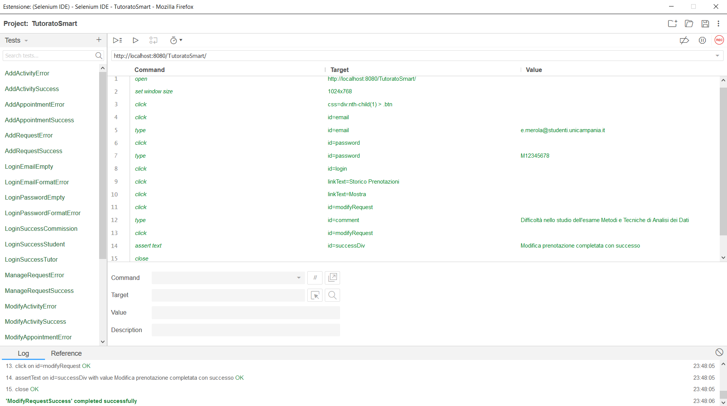

## ModifyRequestError

|  |  |  |
| --- | --- | --- |
| **NOME** | ModifyRequestError | |
| **DATA** | 25/01/20 | |
| **OUTPUT ATTESO** | | |
| Errore | | |
| **OUTPUT SISTEMA** | | |
| Errore | | |
| **ESITO** | | Corretto |

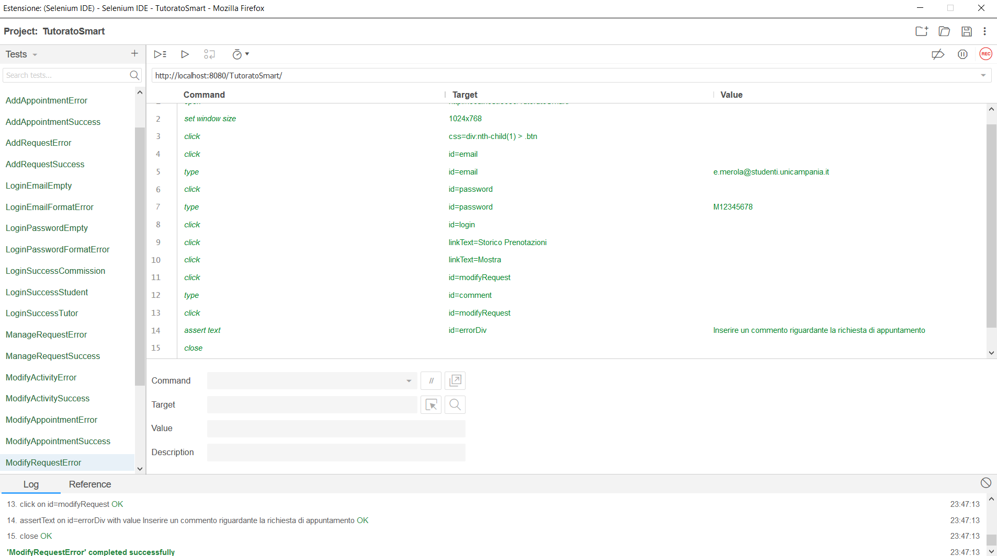

## RegistrationNameFormatError

|  |  |  |
| --- | --- | --- |
| **NOME** | RegistrationNameFormatError | |
| **DATA** | 25/01/20 | |
| **OUTPUT ATTESO** | | |
| Errore | | |
| **OUTPUT SISTEMA** | | |
| Errore | | |
| **ESITO** | | Corretto |

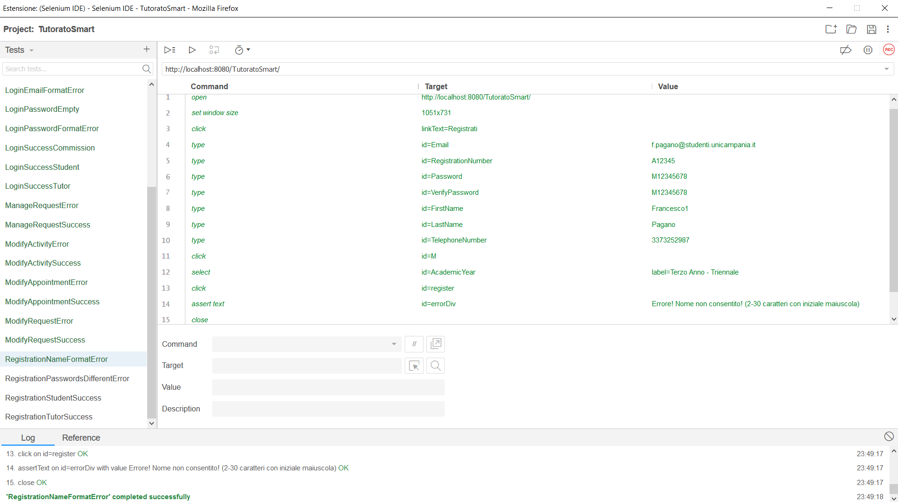

## RegistrationPasswordsDifferentError

|  |  |  |
| --- | --- | --- |
| **NOME** | RegistrationPasswordsDifferentError | |
| **DATA** | 25/01/20 | |
| **OUTPUT ATTESO** | | |
| Errore | | |
| **OUTPUT SISTEMA** | | |
| Errore | | |
| **ESITO** | | Corretto |

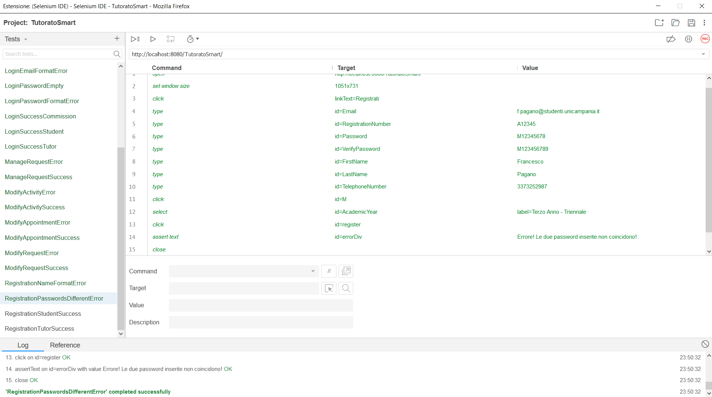

## RegistrationStudentSuccess

|  |  |  |
| --- | --- | --- |
| **NOME** | RegistrationStudentSuccess | |
| **DATA** | 25/01/20 | |
| **OUTPUT ATTESO** | | |
| Errore | | |
| **OUTPUT SISTEMA** | | |
| Errore | | |
| **ESITO** | | Corretto |

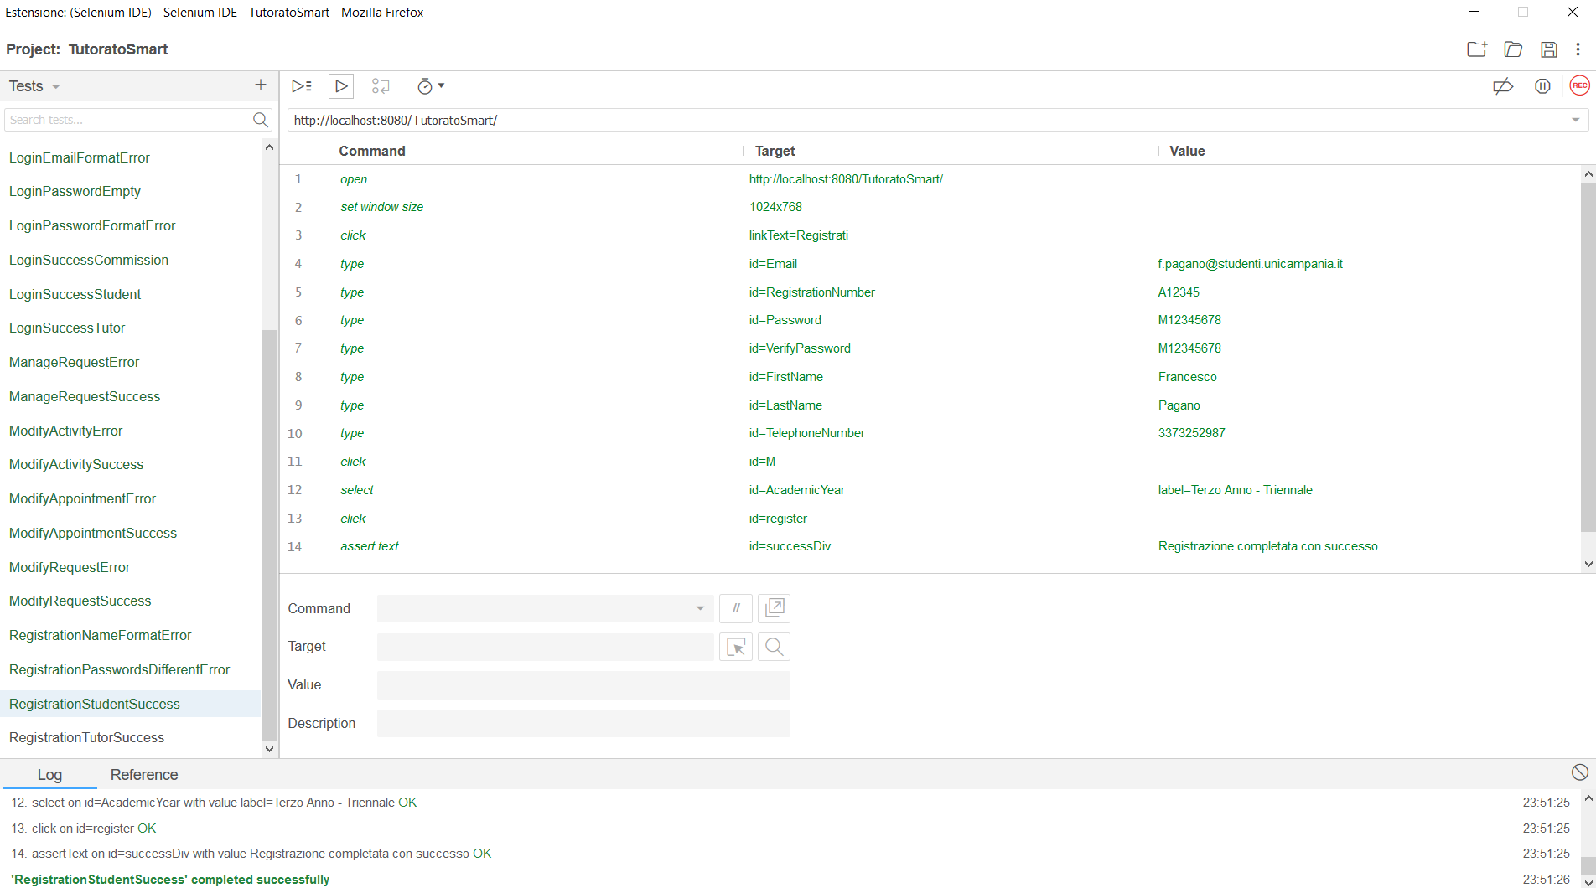

## RegistrationTutorSuccess

|  |  |  |
| --- | --- | --- |
| **NOME** | RegistrationTutorSuccess | |
| **DATA** | 25/01/20 | |
| **OUTPUT ATTESO** | | |
| Corretto | | |
| **OUTPUT SISTEMA** | | |
| Corretto | | |
| **ESITO** | | Corretto |

